Diagnostic Accuracy of Portal Vein Flow Velocity & Hepatic Veins Waveform Morphology in Comparison to Upper GI Endoscopy for Esophageal Varices in Cirrhotic Patients
Abstract
Background: Variceal bleeding is a life-threatening complication of cirrhosis that necessitates urgent detection then management to significantly decrease morbidity & mortality. This study aimed to compare reliability of measuring portal vein flow velocity (PVFV) & hepatic vein waveform morphology (HVWM) with upper GI endoscopy (UGIE) results in the detection & grading of esophageal varices (EV) in cirrhotic patients. Methods: This cross-sectional study was conducted on fifty cirrhotic patients who underwent history taking, clinical examination, laboratory investigations,Child-Pugh-Turcotte, Doppler ultrasound (DUS) assessment followed by UGIE. Results: Patients with EV exhibited significantly larger PV diameter and significantly lower median PVFV as opposed to those without varices. Additionally, monophasic-biphasic HVWM predominated among patients with varices , whereas triphasic morphology was more common in those without varices. ROC curve analysis was done for PVFV to predict the presence of EV suggesting excellent ability to predict it. The best cutoff was ≤16 cm/sec, at which sensitivity, specificity, positive predictive value, and negative predictive value were 70.6%, 87.5%, 92.3%, and 58.3%, respectively. HVWM demonstrated a sensitivity of 55.9% and a specificity of 87.5% for predicting the presence of EV. The positive predictive value was 90.5%, while the negative predictive value was 48.3%. Conclusion: DUS offers a promising, non-invasive tool to assess hemodynamic changes associated with portal hypertension, with parameters such as PVFV and HVWM potentially predicting the presence and severity of EV. Accurate evaluation of these Doppler indices may allow for better risk stratification and reduce unnecessary endoscopies.
Keywords: Cirrhotic; Portal vein flow velocity; Hepatic veins waveform morphology; Esophageal varices; upper GI endoscopy.

Introduction:
Variceal hemorrhage represents a critical and potentially fatal complication of cirrhosis, signifying the onset of vascular decompensation. Significant advances in both the detection and therapeutic approaches for gastroesophageal variants have markedly reduced associated morbidity and mortality rates. According to current guidelines issued by the American Association for the Study of Liver Diseases (AASLD), esophagogastroduodenoscopy (OGD) is advised at the initial diagnosis of cirrhosis to screen for varices and guide prophylactic strategies ^{[1]}.
In the diagnostic evaluations of cirrhosis, imaging plays a central role in identifying structural hepatic alterations. Typical sonographic features include a nodular liver surface, disproportionate lobe sizes; most notably hypertrophy of the caudate lobe and left lateral segment, along with atrophy of the right lobe and left medial segment. Other characteristic findings include dilatation of hepatic fissures, widening of the porta hepatis, and the presence of regenerative nodules. In addition to primary liver findings, secondary signs of portal hypertension (PH) may also be evident. These encompass esophageal and gastric varices, ascitic fluid accumulation, splenomegaly, fatty infiltration of the omentum and mesentery, edematous thickening of the gastrointestinal (GI) wall secondary to venous congestion, and the identification of intrahepatic arterioportal or arteriovenous (AV) shunts ^{[2]}.
In patients with chronic liver disease (CLD), particularly those who progress to cirrhosis, both regional hepatic and systemic hemodynamic alterations become prominent. Doppler ultrasonography (US) serves as a valuable, non-invasive diagnostic tool for assessing these vascular changes. Numerous investigations have employed Doppler US to characterize hemodynamic shifts in cirrhotic patients and to evaluate their responses to medical therapy for PH. Among the Doppler parameters frequently measured are the mean and peak time-averaged velocities of the portal vein (PV), portal vein flow (PVF) volume, and the congestion index (CI), which reflects the ratio of PV diameter (PVD) to blood flow velocity. Additional indicators include effective portal perfusion and resistance indices (RIs) measured in both hepatic and splenic arteries ^{[3]}.
A variety of Doppler-based indices have been employed to estimate the severity of PH in cirrhotic individuals. Of these, hepatic venous waveform (HVW) morphology and PV flow velocity (PVFV) are considered among the most informative. In healthy subjects, the HVW appears as a triphasic pattern, and the normal PV velocity ranges from 20 to 30 cm/s. However, in cirrhosis, the compliance of hepatic parenchyma is significantly reduced, resulting in a transition of the HVW from triphasic to biphasic, and eventually to a monophasic pattern. Concurrently, PV velocity often declines to ≤15 cm/s ^{[4]}.
While OGD remains the gold standard for the detection of esophageal varices (EV), it is not without limitations. The procedure is semi-invasive, may be poorly tolerated by certain patients, and carries potential complications such as gastrointestinal perforation, aspiration, and bacteremia. These concerns have prompted ongoing efforts to identify reliable non-invasive alternatives for the evaluation of varices in patients with cirrhosis ^{[5]}.
In contrast, US is a safe, cost-effective, and widely available imaging modality, suitable for annual or semiannual screening in patients with chronic hepatitis ^{[6]}.
This study aimed to evaluate the reliability of measuring PV flow velocity (PVFV) and HVW patterns as opposed to upper GI endoscopy in detecting and grading EV in patients with liver cirrhosis.
Patients and methods:
Patients:
This prospective cross-sectional study was designed to evaluate the reliability of PVFV measurements and hepatic vein waveform (HVW) morphology in comparison with upper GI endoscopy for the detection and grading of EV in patients with liver cirrhosis. The study was conducted in the Radiology Department at Benha University Hospital over a one-year period, from January 2023 to January 2024.
Informed consent was obtained from all participants prior to enrollment, and ethical approval was secured from the Research Ethics Committee of Benha Faculty of Medicine
Inclusion criteria consisted of cirrhotic patients of both sexes, aged over 40 years, with a disease duration of more than six months.
Exclusion criteria included: clinical or echocardiographic evidence of right-sided heart failure, presence of coexisting respiratory disease, refusal to undergo endoscopy, prior endoscopic variceal ligation (EVL) or sclerotherapy, ongoing acute variceal bleeding, current use of vasodilators or propranolol, and patients who declined participation.
The study enrolled all patients referred from the Gastroenterology and Hepatology outpatient clinic between January 2023 and January 2024 who met the inclusion criteria and consented to participate.
Methods:
All studied cases underwent a comprehensive examination protocol that comprised various elements:
A. Detailed History Taking: This encompassed history of infections such as viral hepatitis or bilharziasis, alcohol intake, episodes of hematemesis, melena, ascites, or lower limb edema, and systemic diseases like renal or cardiac conditions, diabetes mellitus, hyperlipidemia, and hypertension. Details regarding medication use, prior hospital admissions, family history of similar conditions, and personal history—covering age, gender, residence, occupation, socioeconomic status, and special habits—were recorded. Relevant comorbidities including hypertension and diabetes mellitus, past surgical history, and family medical history were also documented.
B. Full Clinical Examination: This involved patient's general condition and vital signs such as temperature, blood pressure, heart rate, respiratory rate, and oxygen saturation were measured. BMI was calculated for each patient; then local abdominal examination including inspecting the abdomen for distension, scars, visible masses, or abnormal movements. Palpation follows, starting lightly to assess tenderness, guarding, or rigidity, and then progressing to deeper palpation to detect masses, organ enlargement (such as the liver, spleen), or ascites. Percussion was carried out to differentiate between areas of gas and dullness and to assess for ascites via shifting dullness. Auscultation involves listening to bowel sounds for their presence, frequency, and character.
C. Laboratory investigations: All patients underwent laboratory evaluation including AST (U/L), ALT (U/L), ALP (U/L), GGT (U/L), total bilirubin (mg/dL), albumin (g/dL), INR, creatinine (mg/dL), serum sodium (mmol/L), hemoglobin (g/dL), and platelet count (×10⁹/L).
D. Child-Pugh-Turcotte (CPT): was originally developed to predict the risk of mortality in patients with liver cirrhosis, particularly to guide the selection of individuals who might benefit from elective surgical procedures such as portal decompression. This system evaluates liver function based on a combination of clinical and laboratory parameters and stratifies patients into three distinct classes. Class A represents patients with well-preserved hepatic function, Class B includes those with moderate functional impairment, and Class C denotes advanced liver dysfunction with the highest risk of perioperative complications and mortality. The CPT score remains a widely employed tool in both clinical practice and research for assessing prognosis and guiding therapeutic decision-making in cirrhotic patients.
E. Doppler Ultrasound Assessment: All patients (men and women aged 40–70 years) underwent Doppler ultrasonographic assessment via convex probes (2–5 MHz, Alpinion and GE P10 devices, Logiq P6 with a 3 MHz pulsed Doppler flowmeter).
F. Endoscopic Assessment: Following Doppler ultrasound, upper GI endoscopy was carried out for all patients by an experienced gastroenterologist. Endoscopic videos were reviewed and interpreted, and EV) were classified according to the adapted Paquet and Palmer-Brick endoscopic criteria.
Hepatic Doppler Ultrasonography Technique Protocol:
Patient Preparation: To ensure optimal conditions, patients were asked to take light meal at night before the exam to reduce colonic gaseous distension.
Positioning: Typically, imaging was carried out with the patient lying comfortably in the supine position, sometimes left lateral decubitus may be needed.

Technique:
The Doppler US assessment was routinely performed using convex transducers operating at 2–5 MHz, combined with a 3 MHz pulsed-wave Doppler flowmeter for vascular evaluation. A single integrated probe was used to conduct both B-mode imaging and color/spectral Doppler analysis, enabling uninterrupted anatomical and hemodynamic assessment. With the patient in a supine position, a longitudinal view of the portal vein (PV) was obtained via either a subcostal or intercostal approach, depending on acoustic access. The Doppler sample volume was positioned at the center of the PV lumen, approximately midway between the confluence of the splenic vein (SV) and superior mesenteric vein (SMV) and the bifurcation of the PV into the right and left branches. The mean portal vein flow velocity (PVFV) was calculated using the first moment of the Doppler power spectrum, providing an accurate estimate of average blood flow. The transducer was then repositioned in the right intercostal space to visualize the hepatic veins (HV) using color Doppler. Spectral Doppler analysis of the HVW was obtained from the right hepatic vein (RHV), typically 3–6 cm from its junction with the inferior vena cava. If the RHV was not well-visualized, the middle hepatic vein (MHV) served as an alternative site. To ensure consistency and minimize respiratory variation, HVW recordings were obtained over at least 5 seconds with the patient instructed to hold their breath at end-expiration. The examination focused on three key parameters: PVD, PVFV, and HVW morphology, each serving as a non-invasive indicator of PH and hepatic vascular status.
Endoscopic Assessment
Patient Preparation: patients were positioned in the left lateral posture. Sedation was administered via Dormicum.
Procedure Technique: Patients were first attached to standard monitoring systems and positioned in the left lateral decubitus position. Once conscious sedation was adequately achieved, EGD was carried out by gently inserting the endoscope under direct visual guidance and advancing it through the esophagus and stomach to reach the second part of the duodenum.
Approval code: MS 7-12-2023
Statistical analysis
The collected data were thoroughly processed through systematic review, coding, and organization to ensure accuracy and consistency. Statistical analysis was conducted via IBM SPSS Statistics version 27 (Armonk, New York, United States). The distribution of quantitative variables was evaluated via the Shapiro-Wilk test along with visual inspection methods. Based on the distribution, normally distributed data were expressed as means and standard deviations, while non-normally distributed data were reported as medians and ranges. Categorical variables were summarized as frequencies and percentages.

For group comparisons, independent t-tests were employed for parametric data, while the Mann–Whitney U test was applied to non-parametric variables. Categorical comparisons were carried out via either the Chi-square test or Fisher’s exact test, depending on the data distribution. To evaluate the diagnostic performance of portal vein flow velocity (PVFV) in predicting EV, receiver operating characteristic (ROC) curve analysis was carried out. The area under the curve (AUC), optimal cutoff value, and relevant diagnostic indices were computed along with 95% confidence intervals (CI). Comparative analysis between HVW morphology and endoscopic findings was carried out to assess diagnostic accuracy. Key performance metrics such as sensitivity, specificity, positive predictive value (PPV), and negative predictive value (NPV) were calculated via cross-tabulation, with upper GI endoscopy serving as the gold standard. Correlations between PVFV and other clinical or sonographic variables were explored via Spearman’s rank correlation coefficient. Furthermore, multivariate logistic regression analysis was employed to identify predictors for both the presence of EV and higher variceal grades, with results presented as odds ratios (ORs) accompanied by 95% CIs. All tests were two-tailed, and p-values<0.05 were considered statistically significant.
Results:
The studied cirrhotic patients had a mean age of 55 ± 10 years. There was a predominance of males (60%) as opposed to females (40%). The mean body mass index (BMI) among patients was 29.9 ± 5.2 kg/m². Table 1
Approximately two-fifths (40%) of the patients demonstrated ascites. Regarding liver function status, CPT class A predominated (60%), followed by class B (36%), while only a minority (4%) were classified as class C. Table 2
Regarding Doppler ultrasound findings, the mean portal vein diameter was 11 ± 3 mm. The median portal vein flow velocity (PVFV) was 16 cm/sec (range: 0–22). For HVW morphology, triphasic pattern predominated (58%), followed by biphasic (26%) and monophasic (16%) patterns. Table 3
Patients with EV exhibited significantly larger portal vein diameter (12 ± 3 vs. 10 ± 4 mm, P=0.049) and significantly lower median portal vein flow velocity (PVFV) (13 vs. 19 cm/sec, P<0.001) as opposed to those without varices. Additionally, monophasic-biphasic HVW morphology predominated among patients with varices (55.9% vs. 12.5%), whereas triphasic morphology was more common in those without varices (87.5% vs. 44.1%, P=0.004). Table 4 and Figure 1 & 2
HVW morphology demonstrated a sensitivity of 55.9% (95% CI: 39.5–71.1) and a specificity of 87.5% (95% CI: 64.0–96.5) for predicting the presence of EV. The positive predictive value was 90.5% (95% CI: 71.1–97.4), while the negative predictive value was 48.3% (95% CI: 31.4–65.6). Table 5 and Figure 3
Case presentation:
Case 1 were illustrated in Figure 4.
Case 2 were illustrated in Figure 5.
Case 3 were illustrated in Figure 6.
Discussion:
According to the current guidelines of AASLD, screening upper GI endoscopy (OGD) is recommended for all patients with cirrhosis at diagnosis, and then at intervals determined by clinical status (Jakab & Garcia-Tsao, 2019) ^{[7]}. However, endoscopy is semi-invasive, uncomfortable, and may be unacceptable to some patients, besides carrying a small but important risk of complications such as aspiration, bacteremia, and rarely, esophageal perforation (Eroglu et al., 2022) ^{[8]}.
Consequently, there has been a global interest in developing and validating non-invasive markers for detecting EV, aiming to avoid unnecessary endoscopies, especially in low-risk patients. Doppler US has emerged as a promising tool by assessing hemodynamic alterations associated with PH, which is the key pathological mechanism underlying the formation of gastro-EV (Kwape et al., 2024) ^{[9]}.
Among Doppler parameters, PVFV and HVW morphology are considered pivotal indicators. A normal HVW exhibits a triphasic pattern, while portal vein velocity (PVV) typically ranges from 20–30 cm/s. In cirrhotic patients, loss of liver compliance alters HVW into biphasic or monophasic patterns, and PVV frequently drops to ≤15 cm/s, reflecting advanced portal hypertension (Onwuka et al., 2022) ^{[10]}.
This study aimed to compare the diagnostic reliability of measuring PVFV and HVW morphology against upper GI endoscopy findings in the detection and grading of EV among cirrhotic patients.
This prospective cross sectional study was conducted on 50 cirrhotic patients . Patients underwent detailed clinical assessment, Doppler US of portal and hepatic veins, and upper GI endoscopy for evaluation of EV. The diagnostic performance of Doppler findings was analyzed and compared with endoscopic results, which served as the reference standard.
In the current study, the presence of EV was associated with older age and lower body mass index (BMI), indicating that advancing age and lower BMI may be potential risk factors for the development of varices in cirrhotic patients. Gender, however, did not appear to influence variceal presence.
In harmony with our findings, Heo and-coauthors investigated whether an acoustic radiation force impulse (ARFI)-based prediction model can assess EV bleeding risk in patients with cirrhosis including 262 patients with cirrhosis; 179 had no EV while 83 had EV and found that patients with EV were significantly older as opposed to those without EV (median age was 57 vs 56, respectively with P= 0.047). Also, patients with EV had lower median BMI (23.6) as opposed to patients without EV (23.7) (Heo et al., 2019) ^{[11]}.
In contrast, Enomoto and-coauthors analyzed a cohort of 794 patients with HCV-related CLD, among whom 90 had histologically confirmed cirrhosis. Within this group, 63 individuals were identified as having compensated cirrhosis—30 with EV and 33 without. The study aimed to assess the association between BMI and the presence of EV, revealing that patients with varices had a significantly higher BMI compared to those without (P = 0.031) (Enomoto et al., 2018) ^{[12]}. In a similar context, Pennisi and-coauthors evaluated 629 patients with NAFLD-related compensated advanced CLD, demonstrating that increasing BMI was significantly linked to the progression of EV (Pennisi et al., 2023) ^{[13]}. The differing results across these studies may be explained by variations in sample sizes, study populations, or methodological approaches.
In the present investigation, the presence of EV was notably associated with a higher prevalence of ascites and more severe liver impairment, as indicated by elevated CPT classifications. These findings support the association between advanced liver dysfunction, fluid accumulation, and the development of varices in patients with cirrhosis.
In accordance with our findings, Omar and-coauthors evaluated the role of fibroscan-measured liver stiffness (LS) in predicting EV and bleeding risk among 250 Egyptian HCV-related cirrhotic patients, via ultrasonographic parameters and modified CPT classification. They reported a stepwise increase in liver disease severity across variceal grades, with CPT class B and C observed only in patients with small or large varices, while 96% of patients without varices were class A (P<0.001). Additionally, ascites was significantly more prevalent among patients with large varices as opposed to those without (11% vs. 2%, P=0.010) (Omar et al., 2023) ^{[14]}.
Also, Eldeeb and-coauthors investigated non-invasive predictors of EV in 125 cirrhotic patients with ascites, via Serum Ascites Albumin Gradient (SAAG) and portal vein congestion index as assessment tools. They found that patients with EV had significantly more advanced liver disease, with 63.2% classified as CPT class C as opposed to 39.5% in the non-EV group (P=0.014) (Eldeeb et al., 2021) ^{[15]}.
In addition, Ebada and-coauthors conducted a cross-sectional study on 100 HCV-related cirrhotic patients, assessing the diagnostic utility of the novel PAPAS index (Platelet/Age/ Phosphatase/AFP/AST) and other non-invasive scores for predicting EV. They found that ascites was significantly more frequent among patients with EV (79.1%) than those without (9.1%, P<0.001). Additionally, they observed that CPT class B and C were significantly more prevalent in the EV group (43.3% and 38.8%, respectively) as opposed to the non-EV group (12.1% class B, 0% class C) (Ebada et al., 2021) ^{[16]}.
Contrastingly, Wasif Khan and-coauthors conducted a cross-sectional validation study on 137 cirrhotic patients to assess the diagnostic accuracy of PVFV measured by Doppler US for predicting EV. Their analysis did not show a statistically significant association between the CPT class and EV presence (P=0.217). Additionally, they reported a higher proportion of ascites among EV patients as opposed to non-EV patients (33.8% vs. 19.6%), but this difference did not reach statistical significance (P=0.071) (Wasif Khan et al., 2023) ^{[17]}.
This study found that patients with EV showed marked liver dysfunction, as evidenced by elevated liver enzymes, bilirubin, and international normalized ratio (INR), along with lower albumin levels and platelet counts. These findings indicate more advanced hepatic impairment and PH in patients with varices. Other parameters, such as aspartate transaminase (AST), creatinine, sodium, and hemoglobin, did not show significant differences, suggesting limited association with variceal presence.
Parallel to our findings, Galal et al. evaluated 101 cirrhotic patients to assess the predictive value of serum fibrosis biomarkers—including platelet count, albumin, and INR—for the presence and severity of EV. They found that patients with EV had significantly lower platelet counts (115 ± 69.5 vs. 145 ± 57.4 × 10⁹/L, P=0.015) and albumin levels (2.95 ± 0.75 vs. 3.29 ± 0.9 g/dL, P=0.045). Also, there was no significant variation in hemoglobin levels between EV patients and no EV patients (10.99±2.16 vs 11.61 ±2.36, respectively with P= 0.184). While contrasting our results, they did not observe statistically significant differences in INR (P=0.078) or bilirubin (P=0.608) between groups, which may be attributed to variability in liver disease severity at baseline or differences in inclusion criteria (Ghada & Khalaf, 2019) ^{[18]}.
Also, Heo and-coauthors found that patients with EV demonstrated significantly lower platelet counts (89 × 10⁹/L vs. 159 × 10⁹/L, P<0.001), lower serum albumin (3.9 vs. 4.2 g/dL, P<0.001), and higher INR (1.1 vs. 1.0, P<0.001), Although they did not observe significant differences in alanine transaminase (ALT) or bilirubin levels between groups (P > 0.05) (Heo et al., 2019) ^{[11]}, this contrast with our results may be attributed to differences in population etiology and the retrospective design of their study, which included both viral and non-viral cirrhosis cases with a focus on bleeding risk stratification rather than variceal presence alone.
In addition, Ebada and-coauthors reported significantly lower platelet counts (108.7 ± 27.3 vs. 178.6 ± 34.3 × 10⁹/L, P<0.001), lower albumin levels (2.92 ± 0.50 vs. 3.57 ± 0.40 g/dL, P<0.001), and higher total bilirubin (1.96 ± 0.86 vs. 1.12 ± 0.42 mg/dL, P<0.001) in EV patients. However, in contrast to our study, they found higher ALT and AST levels in non-EV patients as opposed to EV patients (ALT: 96.3 ± 54.1 vs. 74.4 ± 36.6 U/L, P=0.019; AST: 107.0 ± 51.6 vs. 84.3 ± 41.7 U/L, P=0.020) (Ebada et al., 2021) ^{[16]}. This discrepancy could be attributed to population-specific hepatic enzyme fluctuations or disease progression stage, as elevated transaminases may reflect active hepatocellular injury rather than PH severity.
In the current study, patients with EV showed larger portal vein diameter, reduced PVFV, and a predominance of abnormal HVW patterns. These Doppler ultrasound findings indicate hemodynamic changes and impaired hepatic circulation associated with the presence of varices.
Consistent with our findings, Omar and-coauthors demonstrated that sonographic features such as dilated portal vein diameter and splenomegaly were significantly more frequent in patients with varices, especially in those with large varices as opposed to those with no varices (41% had dilated portal veins vs. 12%, respectively with P < 0.001; 94% had splenomegaly vs. 54%, respectively with P < 0.001) (Omar et al., 2023) ^{[14]}.
Also, Eldeeb and-coauthors found a significantly lower PVFV in patients with varices (11.65 ± 1.38 vs. 14.92 ± 1.14 cm/sec, P<0.001), alongside a significantly increased portal vein diameter expressed as cross-sectional area (1.87 ± 0.12 vs. 1.73 ± 0.14 cm², P<0.001) (Eldeeb et al., 2021) ^{[15]}.
Furthermore, Wasif Khan and-coauthors reported a significantly lower mean PVFV in patients with varices as opposed to those without (13.94 ± 2.61 vs. 20.96 ± 2.35 cm/sec, P<0.001) as well as larger PVD (12.0 ± 1.0 vs. 10.0 ± 1.20 mm, respectively with P=0.012) (Wasif Khan et al., 2023) ^{[17]}.
Similarly, Abdelmonem and-coauthors conducted a cross-sectional study on 48 cirrhotic patients to evaluate the utility of HVW and damping index (DI) in predicting EV. They reported that 96.2% of patients with EV exhibited a monophasic waveform as opposed to 36.4% of patients without EV, while triphasic morphology was preserved in only 40.9% of patients with EV while no EV patients had triphasic phase. These results highlight the monophasic and biphasic HVW as robust non-invasive indicators of the presence of EV and advanced liver dysfunction (Abdelmonem et al., 2022) ^{[19]}.
Contrastingly, Rezayat and-coauthors evaluated 66 cirrhotic patients (46 with EV and 20 without) to assess the role of Doppler US in detecting EV and found no significant differences in portal vein diameter (12.7 mm vs. 12.79 mm, P = 0.912) or PVV (16.86 vs. 18.28 cm/sec, P = 0.424) between groups (Rezayat et al., 2014) ^{[20]}. This discrepancy with our findings may be attributed to methodological differences, particularly the exclusion of HVW analysis
In the present study, ROC curve analysis demonstrated that PVFV has excellent predictive ability for detecting EV. A cutoff value of ≤16 cm/sec provided a strong balance of sensitivity and specificity, supporting its use as a reliable non-invasive screening tool in cirrhotic patients.
In accordance, Wasif Khan and-coauthors demonstrated strong diagnostic utility of PVFV (AUC= 0.981, sensitivity 93.83%, specificity 92.86% at a cutoff of 18 cm/s) to predict EV (Wasif Khan et al., 2023) ^{[17]}.
Also, Elkenawy and-coauthors assessed the diagnostic performance of PVV as a noninvasive screening tool for EV in 135 cirrhotic patients via Doppler US, followed by confirmation with EGD as the gold standard. They reported a higher diagnostic accuracy for PVV, with an AUC of 0.927 (p=0.000), and identified ≥19 cm/sec as the most accurate rule-out cutoff, achieving a sensitivity of 97% and a negative likelihood ratio (LR–) of 0.05 (Elkenawy et al., 2020) ^{[21]}.
The present study revealed that HVW morphology showed high specificity and positive predictive value for detecting EV, indicating it is a reliable marker when abnormal waveforms are present. However, its lower sensitivity and negative predictive value suggest limited utility in confidently ruling out varices when normal waveforms are observed.
In accordance, Abdelmonem and-coauthors reported markedly higher diagnostic performance for HVW morphology, with a sensitivity of 96.2%, specificity of 63.6%, PPV of 75.8%, NPV of 93.3%, and overall accuracy of 81.3% (Abdelmonem et al., 2022) ^{[19]}. The divergence from our findings, particularly in sensitivity and NPV, may be attributed to differences in sample size, population composition, or waveform classification criteria.
In partial agreement with our findings, Shehata and-coauthors conducted a comparative study on 61 cirrhotic patients via Doppler ultrasound and blood indices to identify noninvasive predictors of EV. They reported that monophasic HVW had a PPV of 85% and specificity of 80.95% for predicting EV, along with a sensitivity and NPV of 81.25% for large varices (Shehata et al., 2014) ^{[22]}. Although their reported sensitivity was higher than ours, both studies confirmed the high specificity and PPV of monophasic HVW morphology in detecting varices.
In the current study, abnormal HVW morphology (monophasic-biphasic) was associated with more advanced EV, as higher EV grades (III and IV) were more prevalent in this group. In contrast, triphasic morphology was mostly observed in patients without varices, indicating a potential link between waveform alteration and variceal severity.
In harmony with our results, Abdelmonem and-coauthors reported that 96.2% of patients with EV had a monophasic HVW, while none had a triphasic pattern (P=0.0001). Conversely, 40.9% of patients without varices exhibited a triphasic waveform. These findings demonstrated that monophasic-biphasic HVW is significantly associated with higher EV grades, suggesting advanced PH (Abdelmonem et al., 2022) ^{[19]}.
In our study, multivariate logistic regression analysis identified lower PVFV as an independent predictor of both the presence and severity of EV in cirrhotic patients. Additionally, advancing age was found to be a significant predictor of higher variceal grades, suggesting that hemodynamic impairment and patient age play key roles in the progression of variceal disease.
In harmony with our study results, Khan and-coauthors found that multivariate analysis demonstrated that lower PVFV was strongly associated with the presence of EV (OR=0.120, 95% CI: 0.045–0.322, P<0.001) (Wasif Khan et al., 2023) ^{[17]}.
Also, Elkenawy and-coauthors found that their multivariate regression analysis identified PVV as an independent predictor of EV (adjusted OR=0.418, 95% CI: 0.275–0.637, P=0.001) (Elkenawy et al., 2020) ^{[21]}.
In the present study, multivariate analysis revealed that abnormal HVW (monophasic-biphasic) was a strong independent predictor of both the presence and severity of EV in cirrhotic patients. Additionally, increasing age was significantly associated with higher variceal grades, highlighting the combined influence of altered hepatic hemodynamics and patient age on variceal progression.
In alignment with our results, Joseph and-coauthors assessed the diagnostic value of altered HVW s in predicting large EV among 51 cirrhotic patients. Via Doppler US and endoscopic grading, they reported that the absence of a triphasic waveform (i.e., presence of monophasic or biphasic patterns) was highly sensitive (95.23%) for detecting large varices (grades 3 or 4), with NPV of 75% (Joseph et al., 2011) ^{[23]}. These results closely parallel our findings, supporting the clinical utility of HVW morphology as a reliable non-invasive predictor of EV.
Similarly, Gorka and-coauthors conducted a prospective Doppler-based study on 50 cases with hepatitis C-related cirrhosis to assess the diagnostic accuracy of HVW morphology and portal flow parameters for predicting the severity of EV. They found that a monophasic waveform had a sensitivity of 92% and a specificity of 100% for detecting large varices, while biphasic waveforms showed a lower sensitivity (62%) (Gorka et al., 1997) ^{[24]}.
In contrast to our results, Antil and-coauthors investigated the role of HVW, damping index (DI), and splenoportal index (SPI) in 30 cirrhotic patients and concluded that hepatic venous waveform changes had no predictive value for the presence of EV. While 73.3% of their patients exhibited monophasic waveforms—predominantly in CPT class C—this alteration was significantly associated with liver dysfunction (p<0.05), but not with variceal status (Antil et al., 2016) ^{[25]}. This discrepancy may be explained by their study’s smaller sample size, limited use of endoscopy, and focus on waveform correlation with liver function severity rather than direct logistic modeling of EV prediction.
Conclusion:
Doppler US offers a promising, non-invasive tool to assess hemodynamic changes associated with PH, with parameters such as PVFV and HVW morphology potentially predicting the presence and severity of EV. Accurate evaluation of these Doppler indices may allow for better risk stratification and reduce unnecessary endoscopies.
Funding Statement
The authors affirm that this research was carried out independently and did not receive any form of financial assistance, sponsorship, or grant support from governmental bodies, private industry, or non-profit organizations. All costs associated with the study were covered without external funding, ensuring full academic autonomy.
Author Contributions
All authors contributed equally and collaboratively to every stage of the research process. This included the conception and design of the study, data collection, analysis and interpretation, as well as drafting and critically revising the manuscript for intellectual content. Each author has reviewed and approved the final version of the manuscript and agrees to be accountable for all aspects of the work.
Conflict of Interest Disclosure
The authors declare that there are no actual or potential conflicts of interest with respect to the research, authorship, or publication of this article. No financial, professional, or personal relationships influenced the outcome or integrity of this study.
References:
1. Tawfik N, Tohamy A, El-Shafei T, Habba M. Diagnostic value of spinal ultrasound as opposed to MRI for diagnosis of spinal anomalies in pediatrics. Egyptian Journal of Radiology and Nuclear Medicine. 2020;51.
2. Valente I, Pedicelli A, Piacentini M, Di Serafino M, Vallone G, Speca S, et al. Spinal cord ultrasonography of the newborn. J Ultrasound. 2019;22:113-9.
3. Jeon T, Kim YS, Son HM, Lee SE. Tips for finding magnetic resonance imaging-detected suspicious breast lesions via second-look ultrasonography: a pictorial essay. Ultrasonography. 2022;41:624-32.
4. Ravi KS, Divasha, Hassan SB, Pasi R, Mittra S, Kumar R. Neural tube defects: Different types and brief review of neurulation process and its clinical implication. J Family Med Prim Care. 2021;10:4383-90.
5. Nair N, Sreenivas M, Gupta AK, Kandasamy D, Jana M. Neonatal and infantile spinal sonography: a useful investigation often underutilized. Indian Journal of Radiology and Imaging. 2016;26:493-501.
6. Cohen SP, Bhaskar A, Bhatia A, Buvanendran A, Deer T, Garg S, et al. Consensus practice guidelines on interventions for lumbar facet joint pain from a multispecialty, international working group. Reg Anesth Pain Med. 2020;45:424-67.
7. Jakab SS, Garcia-Tsao G. Screening and Surveillance of Varices in Patients With Cirrhosis. Clin Gastroenterol Hepatol. 2019;17:26-9.
8. Eroglu A, Aydin Y, Ulas AB. Minimally Invasive and Endoscopic Approach to Esophageal Perforation. Eurasian J Med. 2022;54:100-5.
9. Kwape L, Gabriel S, Abdelsalem A, Rose P, Bathobakae L, Peterson D, et al. Evaluation of Noninvasive Tools for Predicting Esophageal Varices in Patients With Cirrhosis at Tygerberg Hospital, Cape Town. Int J Hepatol. 2024;2024:9952610.
10. Onwuka CC, Famurewa OC, Adekanle O, Ayoola OO, Adegbehingbe OO. Hepatic Function Predictive Value of Hepatic Venous Waveform versus Portal Vein Velocity in Liver Cirrhosis. J Med Ultrasound. 2022;30:109-15.
11. Heo JY, Kim BK, Park JY, Kim DY, Ahn SH, Tak WY, et al. Multicenter retrospective risk assessment of esophageal variceal bleeding in patients with cirrhosis: an acoustic radiation force impulse elastography-based prediction model. Gut and Liver. 2019;13:206.
12. Enomoto H, Aizawa N, Ikeda N, Sakai Y, Takata R, Hasegawa K, et al. Association of the Body Mass Index with the Presence of Gastroesophageal Varices in Compensated Cirrhotic Patients with Hepatitis C Viral Infection. Ann Clin Lab Sci. 2018;48:801-4.
13. Pennisi G, Enea M, Viganò M, Schepis F, de Ledinghen V, Berzigotti A, et al. Oesophageal varices predict complications in compensated advanced non-alcoholic fatty liver disease. JHEP reports. 2023;5:100809.
14. Omar M, Salama ZA, Saad Y, Abdelghaffar MM. Fibroscan in Grading and Prediction of the Risk of Bleeding of Gastro-Esophageal Varices in HCV related Cirrhotic Patients. EJHM. 2023;91:5157-61.
15. Eldeeb GS, Hassanein SA, Abd-Elmawla IE, Elabd NS. Role of Serum Ascites Albumin Gradient (SAAG) and Portal Vein Congestion Index as Non-‎ Invasive Methods for Prediction of Esophageal Varices in Cirrhotic Patients‎. AEJI. 2021;11:270-83.
16. Ebada HE, Ebrahim A, Elbareedy A, Salaheldin M, Allam A, Fouad RR, et al. Novel Score for Prediction of Esophageal Varices in HCV-Related‎ Chronic Liver Disease Patients‎. AEJI. 2021;11:343-53.
17. Wasif Khan HM, Bilal B, Khan K, Tariq Butt MO, Ahmad Shah A, Iqbal Aujla U. Diagnostic Accuracy of Portal Vein Flow Velocity for Esophageal Varices in Cirrhotic Patients. Cureus. 2023;15:e43592.
18. Ghada MG, Khalaf S. Clinical Value of Serum Fibrosis Biomarkers in Prediction of Esophageal Varices in Cirrhotic Patients. Med J Cairo Univ. 2019;87:3953-60.
19. Abdelmonem EE, Alghonaimy SS, Soliman AM, Amin MI, Badawy AA. Are Hepatic Vein Waveform and Damping‎ Index Valuable in Prediction of Esophageal‎ Varices in Cirrhotic Patients?‎‎‎. AEJI. 2022;12:269-78.
20. Rezayat KA, Ghanaei FM, Alizadeh A, Shafaghi A, Jandaghi AB. Doppler surrogate endoscopy for screening esophageal varices in patients with cirrhosis. Hepatitis Monthly. 2014;14:e11237.
21. Elkenawy YN, Elarabawy RA, Ahmed LM, Elsawy AA. Portal vein flow velocity as a possible fast noninvasive screening tool for esophageal varices in cirrhotic patients. JGH Open. 2020;4:589-94.
22. Shehata M, AboAli LA, El-Shafey K, El-Hossary M. A comparative study of Duplex Doppler ultrasound and blood indices as noninvasive predictors of oesophageal varices in cirrhotic patients. Tanta Med J. 2014;42:83-91.
23. Joseph T, Madhavan M, Devadas K, Ramakrishnannair VK. Doppler assessment of hepatic venous waves for predicting large varices in cirrhotic patients. Saudi J Gastroenterol. 2011;17:36-9.
24. Gorka W, Al Mulla A, Al Sebayel M, Altraif I, Gorka TS. Qualitative hepatic venous Doppler sonography versus portal flowmetry in predicting the severity of esophageal varices in hepatitis C cirrhosis. AJR. 1997;169:511-5.
25. Antil N, Sureka B, Mittal MK, Malik A, Gupta B, Thukral BB. Hepatic Venous Waveform, Splenoportal and Damping Index in Liver Cirrhosis: Correlation with Child Pugh's Score and Oesophageal Varices. J Clin Diagn Res. 2016;10:Tc01-5.

Table 1. General characteristics of the studied patients (n=50)
General characteristics
Age (years) | Mean ±SD | 55 ±10
Gender
Males | n (%) | 30 (60)
Females | n (%) | 20 (40)
BMI (kg/m²) | Mean ±SD | 29.9 ±5.2
n: number, SD: standard deviation, BMI: body mass index.

Table 2. Clinical characteristics of the studied patients (n=50)
Clinical characteristics
Ascites | n (%) | 20 (40)
Child-Pugh class
A | n (%) | 30 (60)
B | n (%) | 18 (36)
C | n (%) | 2 (4)

Table 3. Doppler ultrasound findings in the studied patients (n=50)
Doppler US findings
PVD (mm) | Mean ±SD | 11 ±3
PVFV (cm/sec) | Median (range) | 16 (0 - 22)
HVW morphology
Triphasic | n (%) | 29 (58)
Biphasic | n (%) | 13 (26)
Monophasic | n (%) | 8 (16)
n: number, SD: standard deviation, PVD: portal vein diameter, PVFV: portal vein flow velocity, HVW: hepatic vein waveform, US: ultrasound.

Table 4. Doppler findings between the studied groups
 |  | EV by endoscopy
 |  | Yes (n=34) | No (n=16) | P-value
PVD (mm) | Mean ±SD | 12 ±3 | 10 ±4 | 0.049*
PVFV (cm/sec) | Median (range) | 13 (0 - 20) | 19 (15 - 22) | <0.001*
HVW morphology
Triphasic | n (%) | 15 (44.1) | 14 (87.5) | 0.004*
Monophasic-Biphasic | n (%) | 19 (55.9) | 2 (12.5) | 0.004*
EV: esophageal varices, n: number, SD: standard deviation, PVD: portal vein diameter, PVFV: portal vein flow velocity, HVW: hepatic vein waveform, *: significant P-value.

Table 5. Diagnostic performance indices of hepatic vein waveform morphology as opposed to endoscopy in predicting presence of esophageal varices
Diagnostic indices
Sensitivity (95% CI) | 55.9 (39.5 - 71.1)
Specificity (95% CI) | 87.5 (64.0 - 96.5)
PPV (95% CI) | 90.5 (71.1 - 97.4)
NPV (95% CI) | 48.3 (31.4 - 65.6)
Accuracy (95% CI) | 66 (52.9 - 79.1)
HVW: hepatic vein waveform, EV: esophageal varices, CI: confidence interval, PPV: positive predictive value, NPV: negative predictive value.

Figure 1. Distribution of associated anomalies in the studied patients.

Figure 2. Distribution of HVW morphology in cirrhotic patients both groups.

Figure 3. Diagnostic performance indices of hepatic vein waveform morphology in predicting presence of esophageal varices.

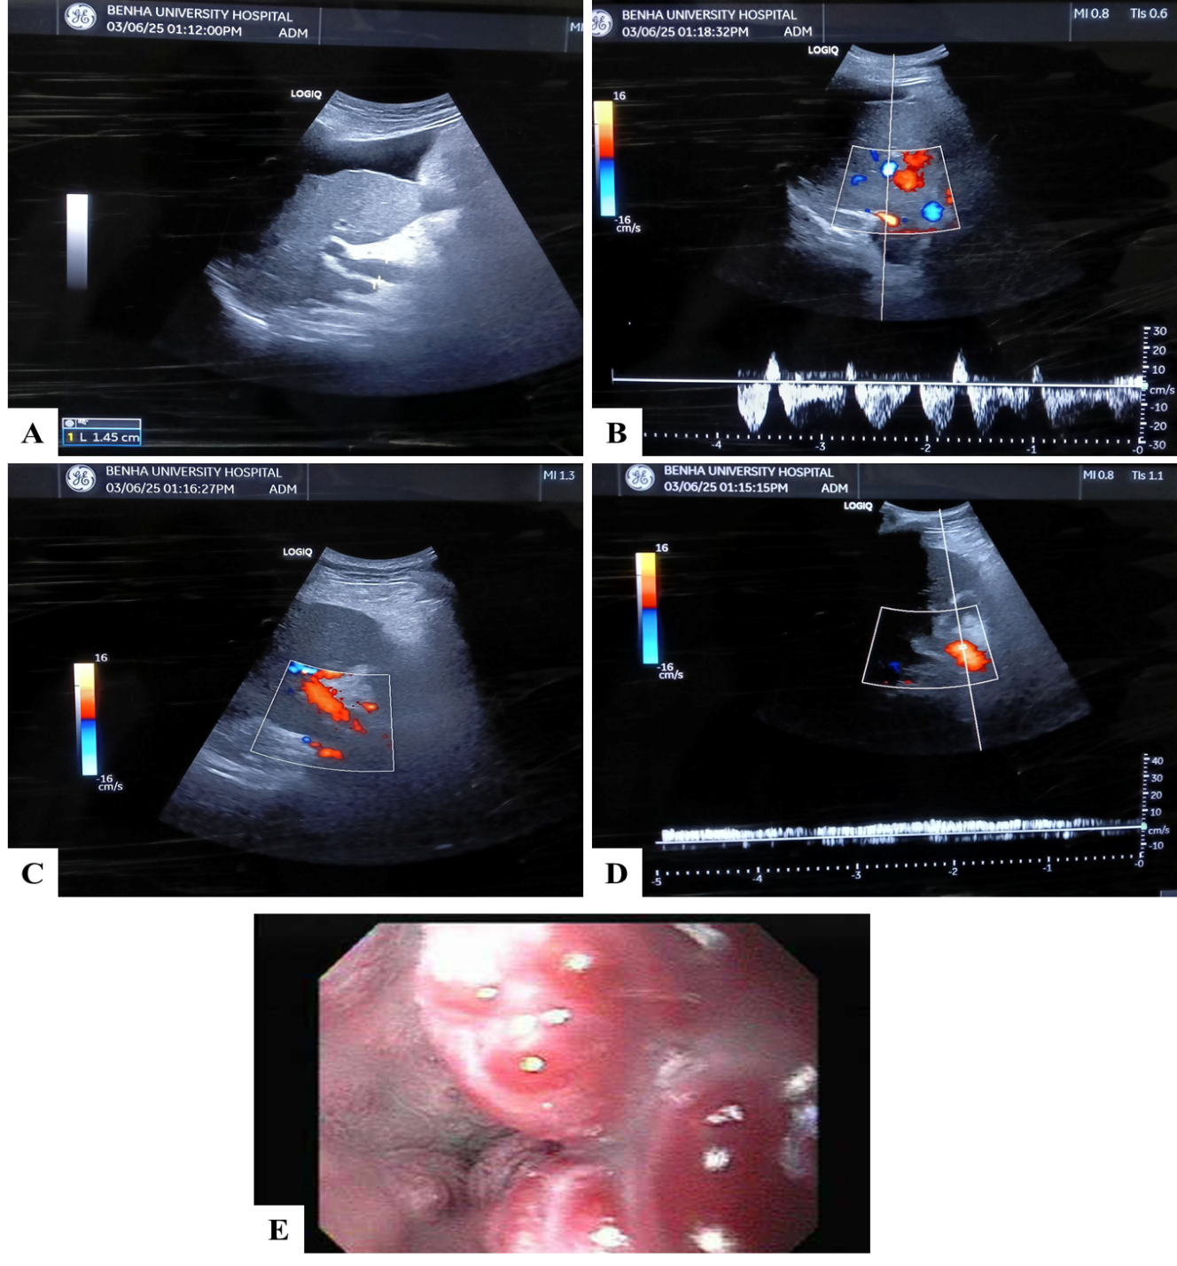
- Figure 4: case 1: A 77-year-old male patient, hypertensive, diabetic, and a heavy smoker, with a history of bilharziasis, presented with hematemesis. He had a BMI of 19, hemoglobin of 9.7 g/dL, INR of 2, platelet count of 94 ×10⁹/L, creatinine of 0.9 mg/dL, and was classified as Child-Pugh class B. A) Cirrhotic liver with ascites & PVD measuring about 14mm. b) Preserved hepatic venous Doppler (triphasic wave pattern). C) Normal hepatopetal color Doppler of PV. D) PV wave pattern with PVFV=8.1cm/sec. E) Upper GI Endoscopy Findings:Three cords esophageal varices (OV) grade III, risky. Agreement between DUS and Upper GI Endoscopy finding =low PVFV consistent with presence of OV, but triphasic hepatic venous wave pattern neither consistent with the presence nor the high grade of OV.
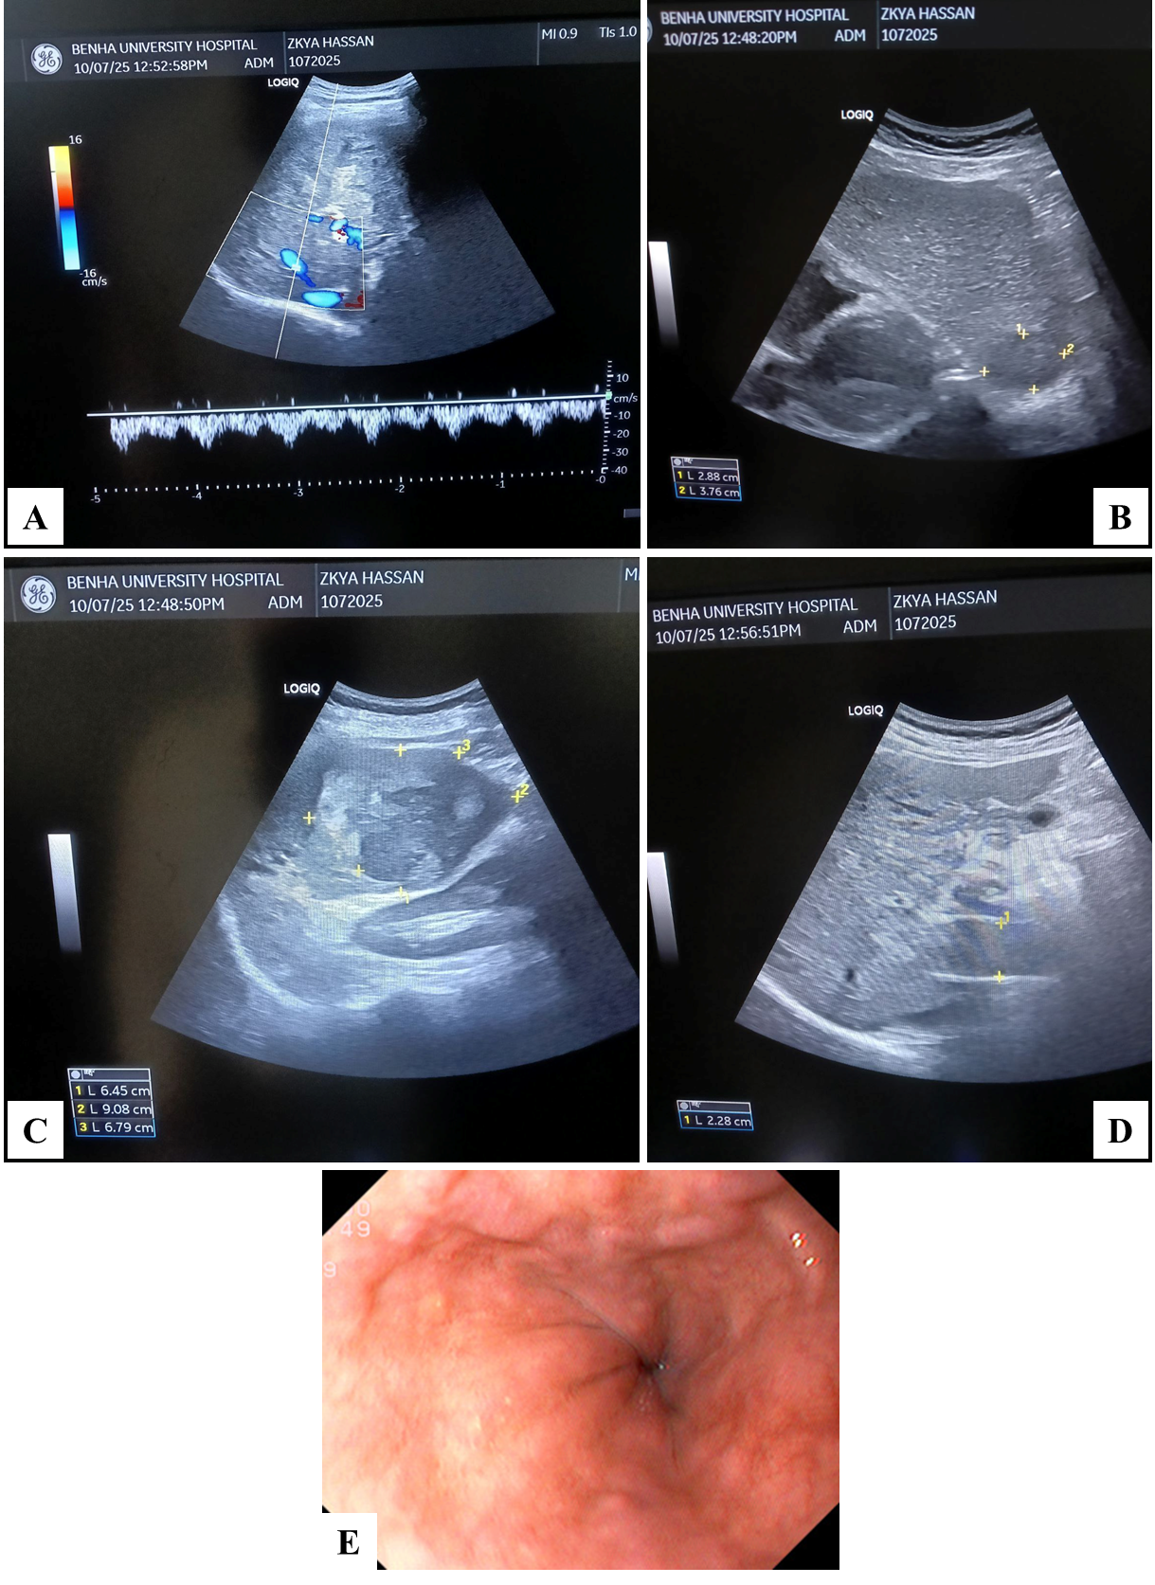

Figure 5: case 2: A 58-year-old male patient, not hypertensive or diabetic, with history of HCV, presented with abdominal pain. BMI: 19, Hb: 11.3 g/dL, INR: 1, platelet count: 262 ×10⁹/L, creatinine: 0.8 mg/dL, Child-Pugh class A. A) Preserved hepatic venous Doppler (triphasic wave pattern). B,C) cirrhotic liver with bilobar hepatic focal lesions proven HCC. D) dilated malignant thrombosed PV, PVFV= zero with PV caliber measuring about 2.28cm. E) Upper GI Endoscopy Findings: four cords OV grade I. Agreement between DUS and Upper GI Endoscopy finding= low PVFV consistent with presence of OV with triphasic hepatic venous wave consistent with low grade OV.
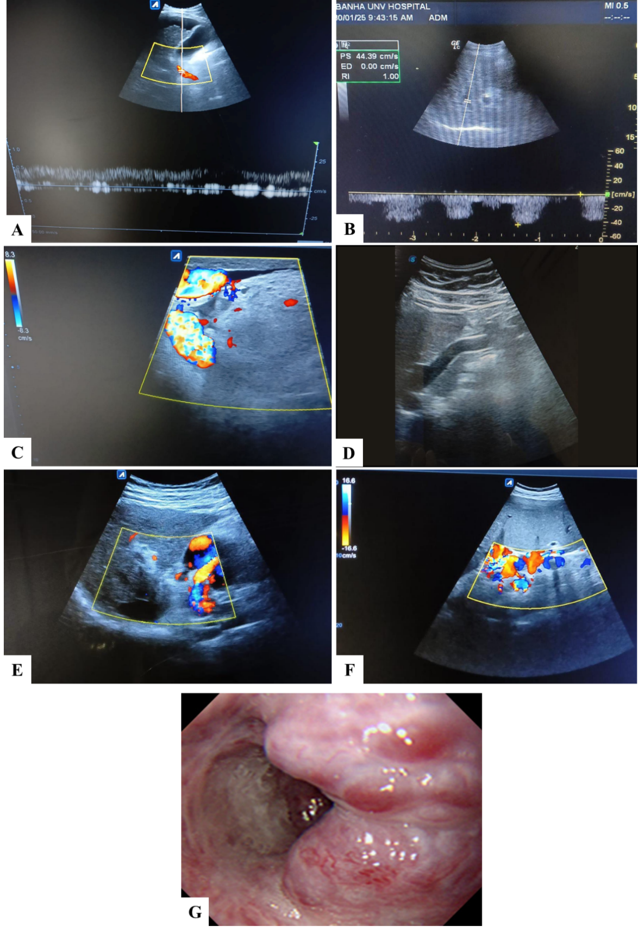
Figure 6: Case 3: A 62-year-old male patient, hypertensive and diabetic, with history of HCV, presented with hematemesis. BMI: 35, Hb: 8.5 g/dL, INR: 1.5, platelet count: 132 ×10⁹/L, creatinine: 1.2 mg/dL, Child-Pugh class B. A) cirrhotic liver with ascites & normal hepatopetal color Doppler of PV with PVFV= 12 cm/sec. B) abnormal hepatic biphasic venous wave. C,D) re-canalized umbilical vein. E) Porta hepatis varices. F) peri-splenic varices. C,D,E,F) porto-systemic collaterals. G) Upper GI Endoscopy Findings: one column OV grade IV risky with cherry red spots. Agreement between DUS and Upper GI Endoscopy finding= low PVFV consistent with presence of OV & biphasic hepatic venous wave consistent with risky high grade OV.

